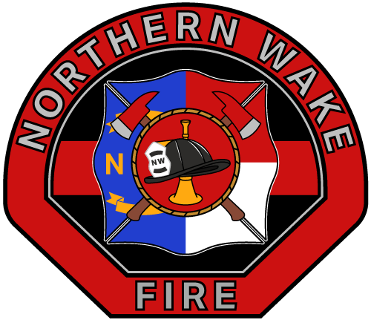
Northern Wake Fire Department
11713 Six Forks Road
Raleigh, NC 27614
Ph: (919) 847-3858
Fax: (919) 847-3892
www.northernwakefire.org

Date:
Members Name:
Address:
City, State, ZIP:
Re: Reimbursement Agreement for Training Expenses

This agreement ("Agreement") is made between Northern Wake Fire Department ("Fire Department") and Members Name: ("Member"), collectively referred to as "Parties," with regard to the reimbursement of expenses associated with attending (“List Class/course name”). Both Parties hereby agree to the terms and conditions outlined below:
Reimbursement of List Class/Course name: Expenses.
The Fire Department agrees to provide financial assistance for the Members training expenses, subject to the following conditions:
- The member shall submit all relevant invoices and receipts within thirty (30) days of successful completion of the training to the Fire Department.
  - If a North Carolina Certification, proof of successful State Certification must be provided.
- The Fire Department will reimburse the Member within sixty (60) days of receiving the invoice and supporting documentation.
  - Total the Fire Department agrees to be Reimbursed:
Reimbursement Conditions: The reimbursement of training expenses is contingent upon the member remaining an active member of the Northern Wake Fire Department ("Department") for a minimum period of one (1) year following the date of reimbursement.

Early Termination: In the event that the member voluntarily leaves or is terminated from the Department within one (1) year of receiving reimbursement for the training expenses, the member shall be obligated to reimburse the Fire Department for the full amount of the expenses incurred, without any pro-rata reductions or adjustments.
Repayment Terms: The Volunteer Firefighter agrees to repay the Fire Department within thirty (30) days of termination of their membership or the termination of this Agreement, whichever occurs first.
- Payment shall be made in a lump sum via certified check or cash.
- The Fire Department reserves the right to deduct these expenses from final compensation at the request of the member, or if the member fails to reimburse the fire department.
Non-Disclosure and Confidentiality: Both Parties agree to maintain the confidentiality of any proprietary, confidential, or sensitive information obtained or disclosed during the course of the members service with the Fire Department. This obligation of confidentiality shall survive the termination of this Agreement.
Entire Agreement: This Agreement constitutes the entire understanding between the Parties and supersedes any prior discussions, negotiations, or agreements, whether written or oral, relating to the subject matter hereof.
Governing Law and Jurisdiction: This Agreement shall be governed by and construed in accordance with the laws of North Carolina, without regard to its conflict of laws principles. Any disputes arising out of or in connection with this Agreement shall be subject to the exclusive jurisdiction of the courts of Wake County, North Carolina.
Please indicate your acceptance of the terms and conditions of this Agreement by signing and returning a copy of this letter to the Fire Department within ten (10) days of receipt.
We appreciate your commitment to the Northern Wake Fire Department and look forward to a successful working relationship. If you have any questions or require further clarification, please do not hesitate to contact us.
Sincerely,

Bart Travis
Fire Chief - Northern Wake Fire Department

I have read and understood the terms and conditions of this Agreement and agree to be bound by them.
Members Name Printed: Members Signature: ________________________
Witness Signature: _____________________
Date:

